Final Project

**Introduction**

**Data Preparation (response(ppg) + division)**

http://www.nba.com/standings

**Simple description of method being used:**

Intro:

Nowadays, basketball is becoming an increasingly popular sport around the world. The National Basketball Association is considered to be the pinnacle of competitive basketball. Evaluating data of team and player has become an important task for team coaches in NBA. The analyses of the statistical reports could help coaches to evaluate the technical and tactical efficiency of players and teams. These data could also enable players to improve basketball skills based on their performance in each team. In NBA, each player belongs to a certain team and team is divided into six divisions, called Atlantic,Central,Northwest,Pacific,Southeast,Southwest respectively. Due to the existence of trading sysytem, the mangers of each team would like to know if a player can improve his peroformance by data analysis. The purpose of this paper is to help determine whether division and team would affect players performance.

In this paper, we use a hierarchical Bayesian approach to model the difference in points per game as a function of the difference of the team and division found in a dataset. Since each team has 13 maximum thirteen players in a game, 13 individual players are assumed to be a random draw from a team. Performance regarding the players are made using the posterior distributions of the division and team parameters.

Data:

The data are obtained from ‘NBAPlayerStatistics0910’ dataset of ‘SportsAnalytics’ library in R[1]. The original dataset contains records of 25 variables for 441 different NBA players. Since the variable division has only two levels (East and West), it would probably not be feasible to place a distribution on the parameters at that level. Therefore, we choose to manually divide teams into six divisions according to NBA division record in 09-10 year. Finally, we will use Team, Division (new created), League as three stages in our project. The team category is the dataset while division category is collected from external source. We also regenerate the response variable Points Per Game(PPG), which is calculated from dividing the value of the toal points (TotalPoints) by the number of games played(GamesPlayed) in the dataset.

[1]<https://www.rdocumentation.org/packages/SportsAnalytics/versions/0.2/topics/NBAPlayerStatistics0910>

**Configuration:**

**Preliminary Experiment**

B:

**Your analysis should include careful specication of your model, explanation of all computational details (initialization, number of chains, convergence diagnostics, Monte Carlo error), and a complete explanation of your nal results and ndings, using Bayesian inference techniques.**

Bayesian Hierarchical Model is used in examination of whether the Points Per Game (PPG) is different in between teams in different divisions. The hierarchical model has four stages, incluidng NBA league, divisions, team and individual player, where division stage has 6 levels, team stage has 5 levels and player stage has 13 levels.

Two different Bayesian Hierarchical Models are performed in this study. The first one is normal hierarchical model where the PPG of each player follows normal distribution, the prior distributions of variance parameters follow inverse gamma distribution, and the prior distribution of population mean follows flat uniform distribution.

|, ~ *N* (,)

|, ~ *N* (,)

|, ~ *N* ($μ_{0}$, $σ_{A}^{2}$)

Prior:

$μ$ ~ 1 du

$σ_{A}^{2}$ ~ *IG* (0.001,0.001)

$σ_{B}^{2}$ ~ *IG* (0.001,0.001)

$σ_{C}^{2}$ ~ *IG* (0.001,0.001)

The second one is gamma hierarchical model where the PPG of each player follows gamma distribution, and prior distributions of all other parameters follows exponential distribution.

|, ~ *Gamma* (,)

| ~ *exp* ()

| ~ *exp* ($φ_{i}$)

$λ_{i}$ ~ *exp* (a)

$φ_{i}$ ~ *exp* (b)

Prior:

a ~ 1 du

b ~ 1 du

The detailed set up for both two models are shown in Figure 1 and Figure 2.



Figure 1. Directed acyclic graph for Normal Bayesian Hierarchical Model



Figure 2. Directed acyclic graph for Gamma Bayesian Hierarchical Model

Executions of both models are performed in OpenBUGS. Each models uses three chains in the simulation and the initialization of parameters in both models are shown in Figure 3.

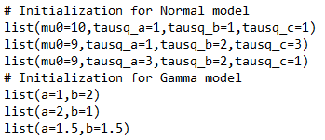

Figure 3. Initialization of parameters in OpenBUGS

In Normal Bayesian Hierarchical Model, we decides to use simulation result from 10,000 to 50,000 after checking the convergence of parameters based on 2,000, 10,000, and 50,000 times simulations respectively. The convergence diagnostics are examined based on output of Brooks Gelman Rubin diagnostic (bgr diagnostic) (Figure 4, 5) and output of history in OpenBUGS (Figure 6,7,8,9).

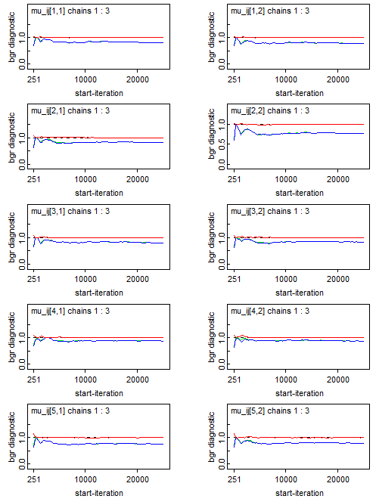

Figure 4. Partial Output of Brooks Gelman Rubin Diagnostic in OpenBUGS for $μ_{ij}$

in Normal Bayesian Hierarchical Model

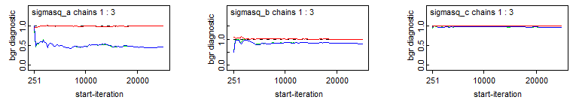

Figure 5. Output of Brooks Gelman Rubin Diagnostic in OpenBUGS for $σ_{A}^{2}$, $σ_{B}^{2}$ and $σ_{C}^{2}$

in Normal Bayesian Hierarchical Model

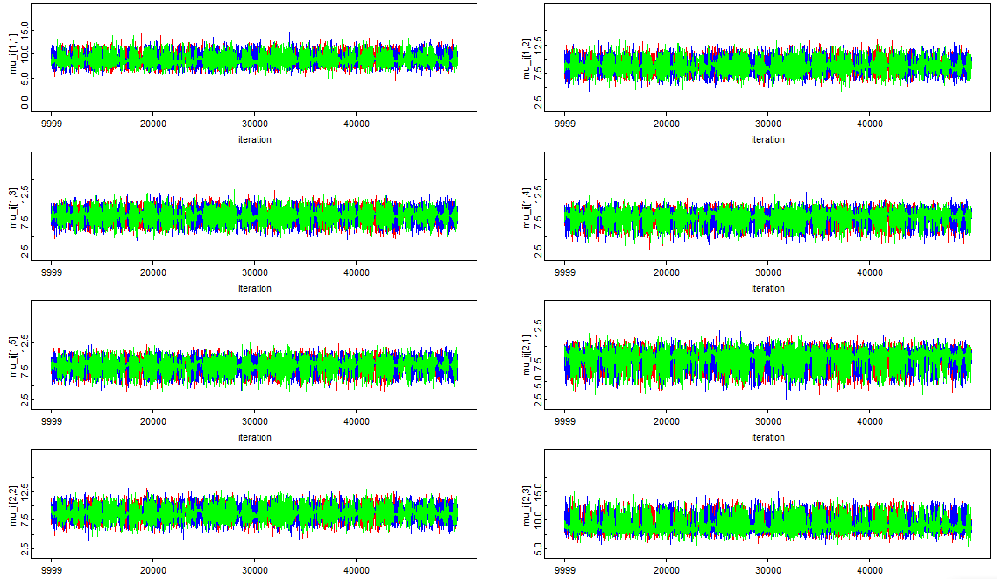

Figure 6. Partial Output of History Diagnostic in OpenBUGS for $μ_{ij}$

in Normal Bayesian Hierarchical Model

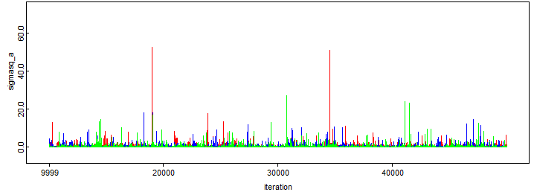

Figure 7. Output of History Diagnostic in OpenBUGS for $σ_{A}^{2}$

in Normal Bayesian Hierarchical Model

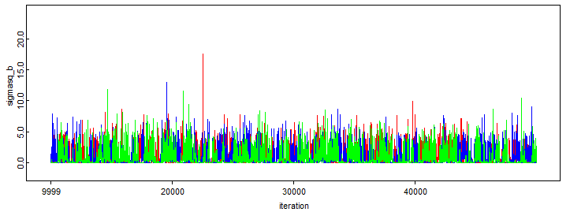Figure 8. Output of History Diagnostic in OpenBUGS for $σ_{B}^{2}$

in Normal Bayesian Hierarchical Model

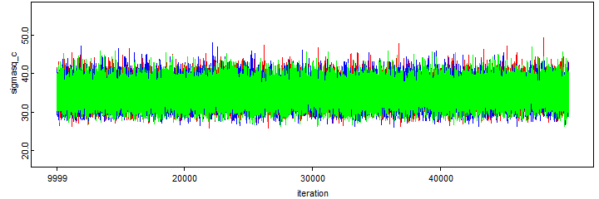

Figure 9. Output of History Diagnostic in OpenBUGS for $σ_{C}^{2}$

in Normal Bayesian Hierarchical Model

Monte Carlo 

Based on the simulation result, there is not any significant differences of Points Per Game between individual teams as well as between different divisions (Table 1,2).

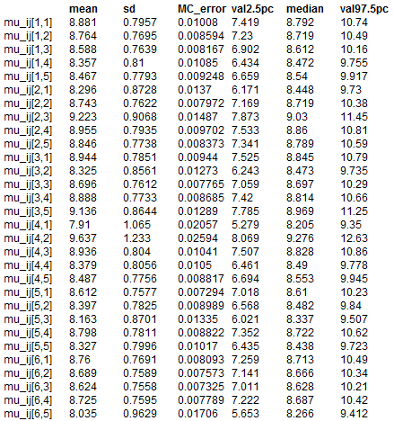

Table 1. Summary Results of Estimates of Points Per Game in Team Level

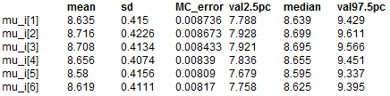

Table 2. Summary Results of Estimates of Points Per Game in Division Level

**Further Exploration**

**Comparison**

C+D:

Sensitivity analysis and comparison with other (possibly frequentist) methods are optional, but desirable. Any important computer code (OpenBUGS or R) that you used should be carefully documented and included as an appendix.

**Conclusion**

**Reference**

Division: <http://www.nba.com/standings/2009/team_record_comparison/conferenceNew_Std_Div.html>



**Appendix**

# Normal Model

model

{

for(i in 1:6){

for(j in 1:5){

for(k in 1:13){

y[k,j,i] ~ dnorm(mu_ij[j],tausq_c)

}

mu_ij[j] ~ dnorm(mu_i[i],tausq_b)

}

mu_i[i] ~ dnorm(mu0,tausq_a)

}

mu0 ~ dflat()

tausq_a ~ dgamma(0.001,0.001)

tausq_b ~ dgamma(0.001,0.001)

tausq_c ~ dgamma(0.001,0.001)

sigmasq_a <- 1/tausq_a

sigmasq_b <- 1/tausq_b

sigmasq_c <- 1/tausq_c

}

list(mu0=10,tausq_a=1,tausq_b=1,tausq_c=1)

list(mu0=9,tausq_a=1,tausq_b=2,tausq_c=3)

list(mu0=9,tausq_a=3,tausq_b=2,tausq_c=1)

# Gamma Model

model

{

for(i in 1:6){

for(j in 1:5){

for(k in 1:13){

y[k,j,i] ~ dgamma(alpha[i,j],beta[i,j])

}

alpha[i,j] ~ dexp(lamda[i])

beta[i,j] ~ dexp(psi[i])

}

lamda[i] ~ dexp(a)

psi[i] ~ dexp(b)

}

a <- dflat()

b <- dflat()

}

list(a=1,b=2)

list(a=2,b=1)

list(a=1.5,b=1.5)

data

list(y=structure(

.Data = c(16.300000,6.111111,5.647059,6.296296,4.391304,14.347826,7.000000,2.444444,10.141026,18.253521,10.125000,13.703704,1.500000,2.400000,4.015873,6.867925,9.805970,16.875000,4.461538,7.777778,7.057971,11.980769,12.464789,18.804878,2.240000,5.304348,11.714286,4.720000,15.276923,3.714286,8.589286,7.373134,15.074074,2.156250,17.722222,6.955882,20.246914,8.166667,6.575758,13.105263,4.691176,8.134146,1.000000,8.739726,8.041096,17.085366,13.750000,5.684211,4.683333,3.375000,8.580645,14.031250,4.954545,17.200000,7.106061,23.971429,10.279412,8.597403,3.392857,11.353659,6.231707,1.950000,3.880952,1.727273,11.283784,0.500000,7.980000,17.5714286,8.963415,10.878378,1.000000,3.938462,4.3461538,8.768293,9.933333,10.734375,5.460317,2.055556,6.339286,2.000000,8.5061728,7.406250,29.710526,18.712121,4.852459,12.0000000,7.345679,3.950000,4.837209,8.565789,8.800000,4.025000,3.270833,9.9682540,5.057971,13.790323,18.065217,9.262500,6.7500000,13.489796,16.643836,3.045455,11.935897,5.521739,9.940299,10.297872,3.0625000,24.145161,8.482759,7.595745,11.679012,10.2105263,3.980769,4.261905,14.583333,7.321429,9.439024,6.464789,15.869565,0.9047619,11.000000,2.750000,10.370370,2.113636,0.8214286,15.463415,6.205479,11.944444,10.390244,15.370370,8.829268,2.058824,5.894737,28.159420,1.076923,19.547945,3.333333,4.290323,13.841463,8.338462,11.500000,3.388889,15.413333,13.000000,1.655172,6.644737,13.506173,10.947368,6.123288,3.179487,17.118421,14.033333,6.718750,3.704225,4.477273,8.219512,2.000000,4.000000,5.853333,30.146341,15.109756,9.907895,6.315068,8.407895,4.716049,1.076923,1.760000,5.963415,3.260870,17.858974,10.135135,8.513514,7.513514,3.857143,8.112903,5.986301,13.975610,2.600000,11.095238,2.666667,4.100000,2.333333,19.474359,2.612245,3.312500,2.642857,11.862069,7.192308,1.472222,9.378049,9.873016,11.634146,13.534247,4.250000,18.671053,13.888889,11.833333,5.030303,17.487500,25.484375,5.377778,4.500000,4.000000,19.814286,5.00000,13.028986,6.243902,11.636364,7.325000,4.777778,11.939024,2.581395,15.266667,4.388889,10.900000,16.854839,4.800000,18.52632,2.092593,9.088235,1.285714,10.974026,8.134146,26.986301,15.030769,7.207317,7.500000,18.307692,2.142857,2.387097,10.75610,2.682540,2.761194,2.379310,4.696203,9.500000,2.745098,1.000000,7.937500,8.219512,11.160494,1.250000,11.259259,0.00000,8.431373,16.456790,15.683544,2.151515,2.826923,10.285714,1.533333,20.138889,8.080000,8.513158,10.041667,16.787500,2.60000,3.324324,0.745098,8.466667,9.125000,0.6666667,18.037975,5.734177,14.172840,1.5714286,21.302632,2.214286,4.269231,3.031250,15.666667,3.211268,0.7692308,1.666667,6.3500000,3.263158,6.529412,11.292683,1.1851852,12.100000,4.289855,2.627907,9.133333,20.580247,7.913793,3.6326531,2.725000,6.0972222,14.820513,7.136986,4.955556,0.8333333,9.884615,4.055556,2.138889,13.571429,8.921053,26.558442,7.0833333,8.211538,7.7301587,8.839506,5.800000,16.586667,3.6172840,18.329268,4.193548,14.069444,12.584615,8.680000,9.609756,6.0121951,22.562500,14.1111111,6.567164,2.500000,10.057143,7.3636364,2.230769,12.742857,4.500000,6.944444,7.833333,6.542373,10.8518518,7.641026,7.089286,16.297297,1.8400000,5.963636,9.142857,10.300000,11.973333,3.413043,25.024691,2.125000,16.623377,7.500000,5.825397,14.888889,7.970149,19.5609756,8.878378,1.200000,1.500000,4.365854,5.191489,5.314286,9.117647,20.565217,16.207317,4.468750,8.810345,2.943662,11.9875000,14.608696,19.587500,1.000000,1.722222,2.320000,2.523810,17.463415,20.753086,3.058824,12.447368,3.250000,0.400000,0.7142857,10.365854,18.688889,7.108696,5.181818,7.240000,12.645161,14.479452,19.024691,3.808824,7.780488,4.392405,7.030769,17.8846154,16.493333,2.106383,2.500000,12.358974,1.666667,12.271605,3.884615,6.341772,5.792208),

.Dim=c(13,5,6)

)

)